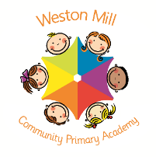

Year 5 and 6

Autumn Term Learning

2020-2021

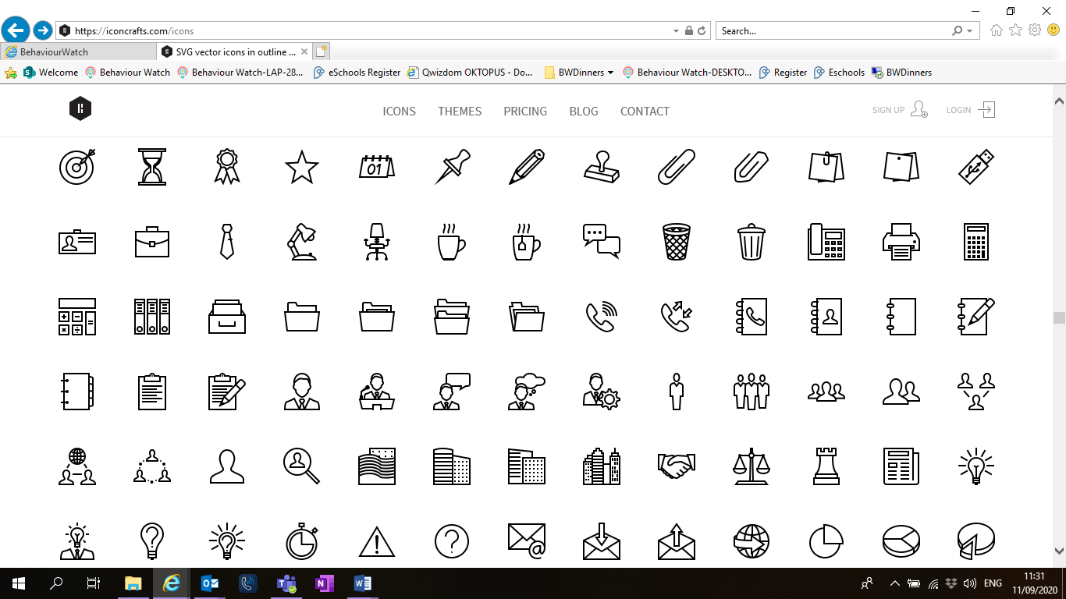

Religious Education and Personal Health and Social Education.

All year groups study a range of religious beliefs in a knowledge capacity. In terms 1 and 2, we will explore What does it mean for Christians to believe God is holy and loving? And What does it mean to be a Muslim in Britain today? In addition to this, in terms 1 and 2 we will focus on What makes up a person’s identity? And What decisions can people make with money?

If you have any questions or would like more information about how to support your child’s learning, please call or email the school office on 01752 365250 or [westonmill.office@discoverymat.co.uk](mailto:westonmill.office@discoverymat.co.uk) and the class teacher will return your call when they are free. Thank you for supporting our safety measures to protect yourselves and our staff and children.

On the reverse, please find an outline of your child’s learning for Term1 and 2.

Coming back to school, we have been focusing on settling in and finding time to catch up with our friends and our new classes initially, before moving onto our traditional style of learning through topics.

We are so pleased to see the school full of children again and we are really impressed with the ambition and maturity that the children have shown since coming back to school.

**How you can help:**

Reading, times tables and spellings are the main areas you can make a huge difference with at home, and these are part of what we expect the children to complete as homework each week. Reading books are changed when the children are ready to change their books in school and they have a Reading Journal that they can bring backwards and forwards from school to track their reading at home. Children are still using the Accelerated Reader programme. Children should try to read with an adult every day; a good guide is at least 10 minutes per day. It is even more helpful if you can ask them questions about what they have been reading, or to predict what they think will happen next.

Each week, your child will be given a list of spellings for their age group. They are tested once a week (from term two onwards). You can really support your child by helping them to learn their spellings at home. A few minutes each evening or as you are walking to or from school will make all the difference.

Children in Year 6 will continue to learn mixed timetables. Children have access to a website called Timestable Rockstars which they will have their password for and it helps them to practice their tables in an engaging way. You can also help by listening to the children recite their tables or asking questions for the children to answer. When your child is competent on one set of times tables, they will then move on to the next ones to learn.

PE

The children will continue to participate in PE sessions each week. **On a PE day, children will be required to come to school in their PE kit for the day.** The children will be going outside and will need suitable outside kit including trainers or plimsolls. School PE kit is a white t-shirt, black or blue shorts, clean socks and trainers or plimsolls. Earrings must be removed for PE by the child, or not worn to school on that day please. Our usual PE day will be: Honeysuckle – Monday, Teasel – Tuesday and Cornflower – Wednesday. We may take part in other outdoor activities during the week, which will be completed in school uniform.



HISTORY: In History, Year 5 and 6 will be exploring the Victorian era. Beginning with Queen Victoria’s reign, we will then learn about key events and look particularly at Victorian children, comparing the difference between Victorian children and modern children.

DT: Drawing influence from our science topic and a highly prominent local landmark, we will design, build and evaluate scaled down model of a working lighthouse.

MATHS: Our work this term will focus on fractions, decimals and percentages, linked to our work on Place Value last term. We will continue to work on key facts recall and support the children with any gaps in knowledge.

PSHE: We will be exploring our identities, thinking about what qualities we have and what makes us unique and individual.



Spanish: We will be covering animals.

TERM 1: Where are we from, where are we going?

Book: Street Child by Berlie Doherty.

SCIENCE: Electricity. In this unit we will explore circuits and how they work, learn to build and draw circuit diagrams and the symbol which represent their components. We also learn about Volts.

TERM 2: Bright Sparks

Book:

RE: In this unit we will be exploring why some people believe in God and why some others do not. We will compare the beliefs and ideas of Christians to those who are non-religious.

SPANISH: This term we will be covering classroom instructions. Focusing on the intonation and expression when speaking.

ENGLISH: As well as continuing to link reading and writing objectives to the STEM subjects, this term we are covering Non-fiction texts such as Biographies related to famous scientists who work with electricity and letters of persuasion around the notion of green energy.

ART: We will be exploring single point perspective pencil drawings linked to classical Victorian architecture. We will be building on the tone and light techniques from previous years.

ENGLISH: Year 5 and 6 will start the term focusing on narrative writing linked to this term’s key text: Street Child. Year 5 and 6 will begin by looking back in history during the Victorian era, which will lead us to focus upon naturalist Charles Darwin and his discoveries aboard HMS Beagle. Year 6 will delve into Charles Darwin’s discoveries, by exploring non-fiction reading and writing.

SCIENCE: Evolution and Inheritance. This topic gives us our theme title and will be linked to many of the reading and writing objectives covered. We will be learning about the characteristics we get from our parents and evolution.

MATHS :Our priority this term is to reinforce prior learning of place value and the four mathematical operations, as well as consolidating these principles to answer a range of mental and written problems. An emphasis will also be placed on developing a secure recall of number facts and times tables.