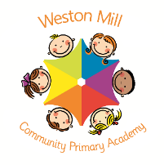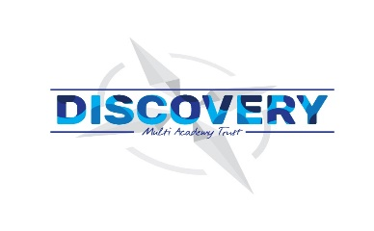

Year 2/3

Autumn Term Learning

2020-2021

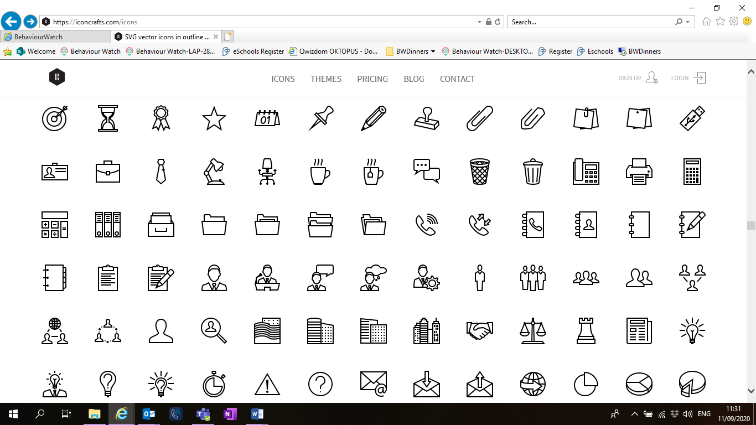

If you have any questions or would like more information about how to support your child’s learning, please call or email the school office on 01752 365250 or [westonmill.office@discoverymat.co.uk](mailto:westonmill.office@discoverymat.co.uk) and the class teacher will return your call when they are free. Thank you for supporting our safety measures to protect yourselves and our staff and children.

On the reverse, please find an outline of your child’s learning for Term1 and 2.

Coming back to school, we have been focusing on settling in and finding time to catch up with our friends and our new classes initially, before moving onto our traditional style of learning through topics.

We are so pleased to see the school full of children again and we are really impressed with the ambition and maturity that the children have shown since coming back to school.

**How you can help:**

Reading, times tables and spellings are the main areas you can make a huge difference with at home, and these are part of what we expect the children to complete as homework each week. Reading books are changed when the children are ready to change their books in school and they have a Reading Journal that they can bring backwards and forwards from school to track their reading at home. Children are still using the Renaissance Reading program. Children should try to read with an adult every day; a good guide is15 mins per day. It is even more helpful if you can ask them questions about what they have been reading, or to predict what they think will happen next.

Each week, your child will be given a list of spellings for their age group. They are tested once a week. You can really support your child by helping them to learn their spellings at home. A few minutes each evening or as you are walking to or from school will make all the difference.

Children in Y2/3 will learn 2,5,10,3 & 4 timetables. Children have access to a website called Times table Rock stars, which they will have their password for, and it helps them to practice their tables in an engaging way. You can also help by listening to the children recite their tables or asking questions for the children to answer. When your child is competent on one set of times tables, they will then move on to the next ones to learn.

Religious Education and Personal Health and Social Education.

All year groups study a range of religious beliefs in a knowledge capacity. In terms 1 and 2, we will explore what Christians learn from the creation story and what it is like for someone to follow God. In addition to this, in terms 1 and 2 we will focus on how we can be a good friend as well as how to keep safe,

PE

The children will continue to participate in PE sessions each week. **On a PE day, Friday for Violet Class and Thursday for Dandelion**, **children will be required to come to school in their PE kit for the day.** The children will be going outside and will need suitable outside kit including trainers or plimsolls. School PE kit is a white t-shirt, black or blue shorts, clean socks and trainers or plimsolls. Earrings must be removed for PE by the child, or not worn to school on that day please. Despite our usual PE days, we may also take part in other outdoor activities during the week, which will be completed in school uniform.



HISTORY: In history, we will be continuing to travel through time to the Iron Age to investigate the advances in technology and the use of tools. We will be focusing on the achievements of ancient civilizations including Stone Henge and Skara Brae.

COMPUTING: The children will be conducting research using the internet. They will learn how to use a search engine effectively and how to stay safe when online and using technology.

TERM 2: FIGHTING FIT

Book: Beowulf.

SCIENCE: This term we will be investigating the human body and asking why we need a skeleton as well as exploring the roles the different muscles and bones in our body, including our teeth!

MATHS: Children will be using their knowledge of place value taught in Term 1 to focus on subtraction, including formal written methods. We will then begin work on multiplication, including learning our three and 4 times tables. The children will learn about different mental and written methods that they can use to multiply two numbers together.

TERM 1: ROCKS

Book: Escape from Pompeii

ENGLISH: We will be learning about myths and legends, in particular the legend of Beowulf. From this, the children will be writing their own action packed, monster filled legends. We will then be creating specialized dictionaries following on from our vocabulary work in science. The children will create their own alphabetized dictionary about the human body.

ART: This term the children will be experimenting with the medium of charcoal in order to create a self-portrait, which has a range of tone.

HISTORY/GEOGRAPHY: In our history lessons, we are going to be archeologists, learning about artefacts from the past and exploring what they can tell us about how Britain has changed since the Stone Age. Our Geography learning links with our focus text, we will be describing human geography such as cities and villages as well as physical geography – learning about mountains and volcanoes.

SPANISH: We will be learning how to say basic greetings such as Good Morning and goodbye. We will be practicing having short conversations in Spanish with our partners.

ENGLISH: We will be using our focus book to teach the about persuasive arguments, in which children will write a persuasive letter to the villagers of Pompeii convincing them to flee he eruption of Mount Vesuvius. After that, we will be delving into non-fiction texts in which the children will conduct research into different types of rocks in order to create a page from a non-fiction book.

MATHS: In maths, we will be building upon our prior knowledge of place value and addition. We will be using resources such as base 10 and bead strings to help us add and subtract tens as well as represent different numbers to 1,000.

MUSIC: This term we will be learning how to play the ukulele. We will be experimenting with chords and using them to create simple tunes that we can sing along to.

PSHE: We will be thinking about how we can be a good friend and which qualities we would like in a friend. We will also be talking about loneliness and what we can do if we feel lonely.

SCIENCE: This term we will be exploring and comparing the different types of naturally occurring rock. We will also be creating an excavating our own fossils.