**SEND Information Report – 2022**

**Vision Statement:**

We believe in developing a child intellectually, creatively, emotionally, physically, spiritually, culturally and morally.

This will take place in the caring and supportive environment of a school that aspires to be outstanding and that is proud to be at the heart of the local and wider community, raising standards of attainment for all pupils.

We want our children to be confident, happy and healthy individuals, successful learners and responsible citizens.

**What is SEN?**

The special educational needs code of practice (2015) says that:

“A pupil has SEN where their learning difficulty or disability calls for special educational provision, namely provision different from or additional to that normally available to pupils of the same age”.

This means that a pupil may need:

* Special resources to help them in the classroom.
* To be part of a small group with an adult to help them with their work, their social skills or their emotional well being.
* To work with someone specially trained to help them in the area that they need. (Usually someone from outside school).
* Have an IEP (individual education plan) which will contain a simple summery of what is important to the child and how they would like to be supported. This will be shared with parents to set targets and review regularly.



There are four areas where a pupil may have a difficulty that means they are considered to have SEN.

They are:

* **Communication and interaction** – this includes speech and language and social communication difficulties which includes Autism.



* **Cognition and learning** – this is where a pupil is learning at a slower pace than others in their year group.



* **Social, emotional and mental health** – this includes pupils with challenging behaviour, anxiety, ADD (attention deficit disorder), ADHD (attention, deficit, hyperactivity disorder) or attachment disorder.



* **Sensory and/or physical needs** – this includes hearing difficulties, visual difficulties, mobility difficulties and sensory processing difficulties.

A pupil may have difficulty in one area or, more than one area.

**Who is responsible for the pupils with SEN?**

Mrs Clare Burch is our school Inclusion Coordinator (INCO) and can be contacted through the school office.

Mrs Seaman and Mrs Triscott are specially trained practitioners that work in the HUT. They are led by our Inclusion Coordinator (INCO).



**Who can I contact for advice and support for my family?**

* Mrs Claire Fletcher-Wilkinson is our Family Support Advisor (FSA) and can be contacted through the school office.

* PIASS – Plymouth Information Advice and Support for SEND can provide impartial and confidential information and support for parents and carers which can include:

- Helping with reports, letters and any paperwork

- Attending meetings

- Signposting to other groups or organisations.

- Visiting schools to help with making informed choices.

**[](https://www.plymouthias.org.uk/)**

**How will the school know my child needs special educational provision?**

* Little or no progress is being made. Teachers will know this because:
* They continually assess the children as part of their daily teaching. If needed, some children will then receive additional support as part of a group or on their own with an adult.
* They meet termly to look at the progress all pupils are making and identify any who are not making progress or who have made slow progress, so that they can support them.
* They will review support and interventions regularly to make sure progress is being made.
* Some pupils will have an IEP which will be shared with parents, reviewed and renewed regularly.
* School will be alerted by parents with their concerns.
* Child is struggling to adhere to the Managing and Supporting Behaviour Policy.
* School will be alerted by other professionals working with the child or family outside of school.

**How can I let the school know I am concerned about my child?**

* First, talk to your child’s teacher. If necessary, they will talk to the INCO about your concerns. The teacher will let you know what will happen next.
* If you are still concerned you can ask to meet with the INCO.
* You could also ask to see the Head of School or the Assistant Head of School.

**How will the school let me know if they have any concerns about my child’s learning?**

* The class teacher will talk to you.
* Any concerns will be shared at Parents’ Evenings or in reports.
* You will be invited to a meeting in school with relevant staff.



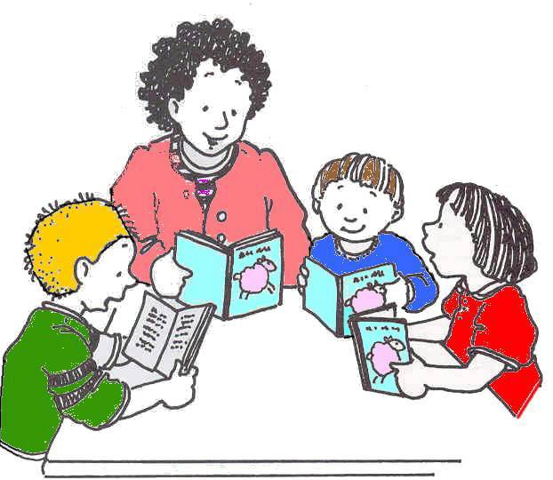**What are the different types of support available for children with special educational needs?**

* Resources that are related to the child’s needs.
* Teaching that is appropriate to the needs of the child.
* Small group work:
* English intervention
* Maths intervention
* Social skills groups
* Motor skills groups
* Emotional Literacy support groups (managing emotions, self esteem, friendships, anxiety and bereavement)
* Access to The HUT and HUT staff
* THRIVE
* Support from an adult (teacher, teaching assistant, pastoral support worker, INCO, speech and language therapist)
* Family Support Advisor (FSA)
* Sometimes we access support from other people outside of school, these include:
* Multi-agency support team (MAST)
* Communication Interaction Team (CIT)
* Death Awareness Team
* Woodlands Outreach for children with physical difficulties
* Educational Psychologist
* Plymouth Information Advice and Support Service (PIASS, formally Parent Partnership)
* School Nurse
* Child and Adolescent Mental Health Service (CAMHS)
* NHS Speech and Language Team
* Plymouth Primary Nurture
* Other specialist provision.

More information about the Local Authority’s Local Offer for children and young people with SEN and their families as well as the above services can be found on the Plymouth Online Directory (POD).

[**http://www.plymouthonlinedirectory.com/**](http://www.plymouthonlinedirectory.com/)

**How are the adults in school helped to work with children with SEN?**

* The INCO is a qualified teacher who has the skills and experience to work with and support staff and children with SEN.
* Staff training takes place regularly to help all staff understand and teach children with SEN.
* Individual teachers and support staff attend training courses run by outside agencies that are relevant to the needs of the children.

**How do parents/carers and children with SEN share their views, concerns and work with the school?**

* Surveys and Questionnaires.
* Parents Evening.
* IEP Reviews.
* Regular meetings, including EHAT (Early Help Assessment Tool) and TAM (Team Around Me) meetings.
* Annual Reviews for pupils with statements and EHC (Education, Health and Care) plans.
* 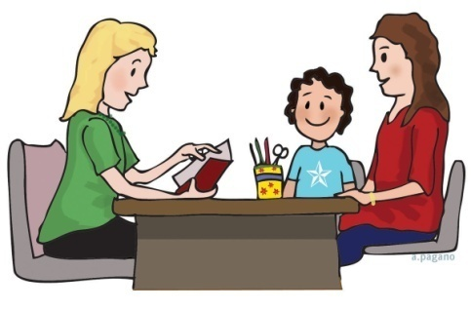School champions.
* Person Centred Planning meetings, where appropriate.

**If I have a query about the support my child receives, what do I do?**

* Talk to your child’s teacher.
* Ask to meet the INCO.
* Ask to meet the Head of School or the Assistant Head of School.

**If I am not happy with the support my child is getting what can I do?**

* Talk to your child’s teacher.
* Ask to meet with the INCO.
* Ask to meet with the Head of School or Assistant Head of School.
* Request a copy of the Discovery Mat’s Complaints Policy from the school office.

**What happens when my child moves from class to class or to another school?**

* All children make visits to their new class and teacher in the summer term.
* Class teachers meet in the summer term to pass on information about all pupils and their individual needs.
* Some children will have a transition booklet to take home over the holidays with pictures and information about their new class or school.
* The new class teacher will be part of the IEP review’s in the summer term and pupils will have the opportunity to update their strengths and what they need in school to help them.
* Additional visits may be arranged to reassure more anxious children.
* Appropriate information about a child is passed to new schools with parental permission.

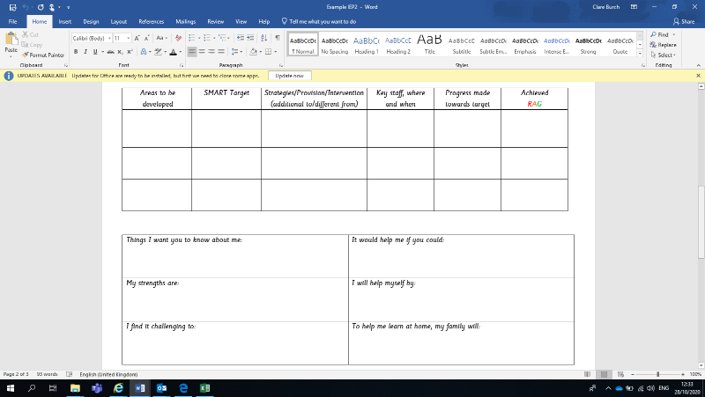

**How accessible is the school for my child with SEN?**

* The school is set out across two floors with classrooms situated on the ground floor.
* Two stairways and a lift provide access to the first floor.
* There are two designated parking spaces for Blue Badge Holders.
* Weston Mill accessibility plan is available at <https://www.westonmill.plymouth.sch.uk/>

**Where can I find information about the school’s approach to pupils with SEN?**

* Full details can be found in the school’s SEND Policy, which is available on the school website <https://www.westonmill.plymouth.sch.uk/web/sen_information>

Our school is proud to be a Mentally Healthy Organisation (TISUK) and a Centre of Excellence (Inclusion Quality Mark).

Thank you to all the parents from Weston Mill who complete the Parent Survey annually which impacts the provision for our children with SEND. (Last received Jan 22)

Updated February 2022