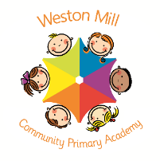

Year 2

Autumn Term Learning

2020-2021

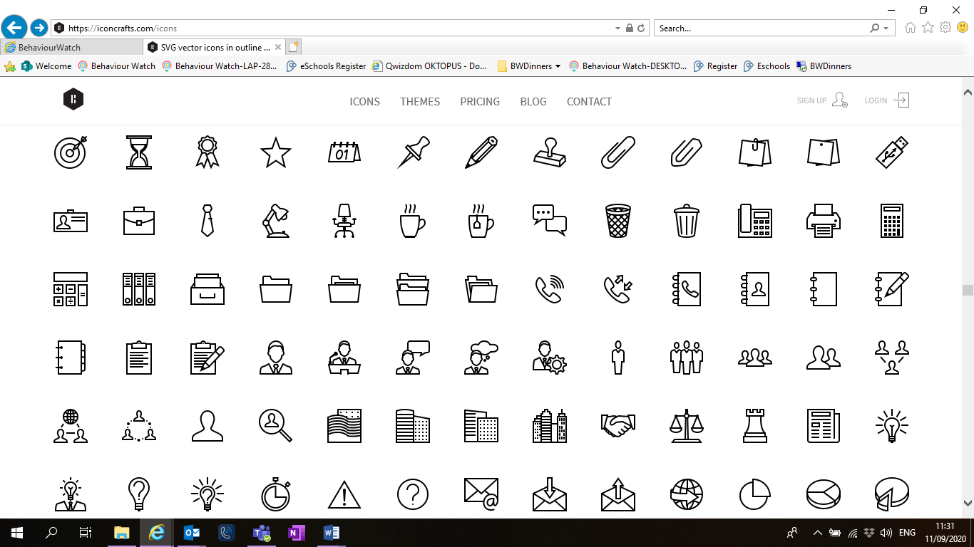

If you have any questions or would like more information about how to support your child’s learning, please call or email the school office on 01752 365250 or [westonmill.office@discoverymat.co.uk](mailto:westonmill.office@discoverymat.co.uk) and the class teacher will return your call when they are free. Thank you for supporting our safety measures to protect yourselves and our staff and children.

On the reverse, please find an outline of your child’s learning for Term1 and 2.

Coming back to school ,we have been focusing on settling in and finding time to catch up with our friends and our new classes initially, before moving onto our traditional style of learning through topics.

We are so pleased to see the school full of children again and we are really impressed with the ambition and maturity that the children have shown since coming back to school.

**How you can help:**

Reading, times tables and spellings are the main areas you can make a huge difference with at home, and these are part of what we expect the children to complete as homework each week. Reading books are changed when the children are ready to change their books in school and they have a Reading Journal that they can bring backwards and forwards from school to track their reading at home. Children should try to read with an adult every day; a good guide is 10 mins per day. It is even more helpful if you can ask them questions about what they have been reading, or to predict what they think will happen next.

Each week, your child will be given a list of spellings for their age group. They are tested once a week. You can really support your child by helping them to learn their spellings at home. A few minutes each evening or as you are walking to or from school will make all the difference.

Children in Year 2 will learn 2. 5. 10 and 3 timetables. Children have access to a website called Timestable Rockstars which they will have their password for and it helps them to practice their tables in an engaging way. You can also help by listening to the children recite their tables or asking questions for the children to answer. When your child is competent on one set of times tables, they will then move on to the next ones to learn.

Religious Education and Personal Health and Social Education.

All year groups study a range of religious beliefs in a knowledge capacity. In terms 1 and 2, we will explore Rules and Routines and Light and dark.

In addition to this, in terms 1 and 2 we will focus on What makes a good friend and What is Bullying?

PE

The children will continue to participate in PE sessions each week. **On a Friday, children will be required to come to school in their PE kit for the day.** The children will be going outside and will need suitable outside kit including trainers or plimsolls. School PE kit is a white t-shirt, black or blue shorts, clean socks and trainers or plimsolls. Earrings must be removed for PE by the child, or not worn to school on that day please. Our usual PE day will be **Friday**; however, we may take part in other outdoor activities during the week, which will be completed in school uniform.



MATHS

We will continue addition and subtraction problem solving and then move on to money, recognizing coins and making amounts.

TERM 2: Habitats

Book: Where is my home? By Lucy Parrianen

SCIENCE

We will study animal habitats and how the habitat provides for the animal. We will also investigate how the animal can support its habitat.

PSHE

We will find out what bullying is and what we should do if we think we are being bullied.

GEOGRAPHY

We will visit Africa in our imaginations and find out about it and the animals that live there comparing it with where we live in England.

D&T

We will design, create and evaluate our own animal shelters. Deciding what kind of shelter our animal would need and which materials we would create it out of.

RWI

This term we will using our sounds to sound out and blend words to read.

ENGLISH

This term we will focus on story settings and how to write a descriptive setting. We will then study information texts about habitats to research and find out about the places animals live.

COMPUTING

We will be working on algorithms and using our algorithms to first guide each other and then guide a Bee Bot around a route.

RWI

This term we will be focusing on our sounds from set 2 and 3 and using these to spell and write words.

MUSIC and DT

We will be creating a moving animal puppet using split pins and pullies. In music we will study the carnival of the animals by **Camille Saint-Saëns.**

TERM 1: Animals and moving around

Book: The enormous turnip, The Gingerbread man

PSHE

We will find out what makes a good friend and how can be good friends to each other.

ENGLISH

We are going to be studying the traditional tales ‘The Gingerbread man’ and ‘The enormous turnip’ both of these stories have lots of animal characters in them. By the end of the first half term we are going to rewrite one of these stories with our own animals in it!

SCIENCE

We will learn about five of the groups that scientists use to classify animals: mammals, fish, birds, reptiles and amphibians. We will find out how animals and humans change as they grow from babies to adults.

MATHS

This term we are going to be looking at place value and how our numbers are made up of tens and ones. Then we are then going to solve addition and subtraction problems using counting on, bar models and number lines.