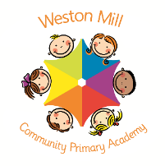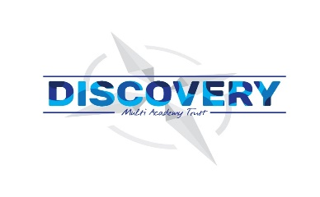

Year 4

Autumn Term Learning

2020-2021

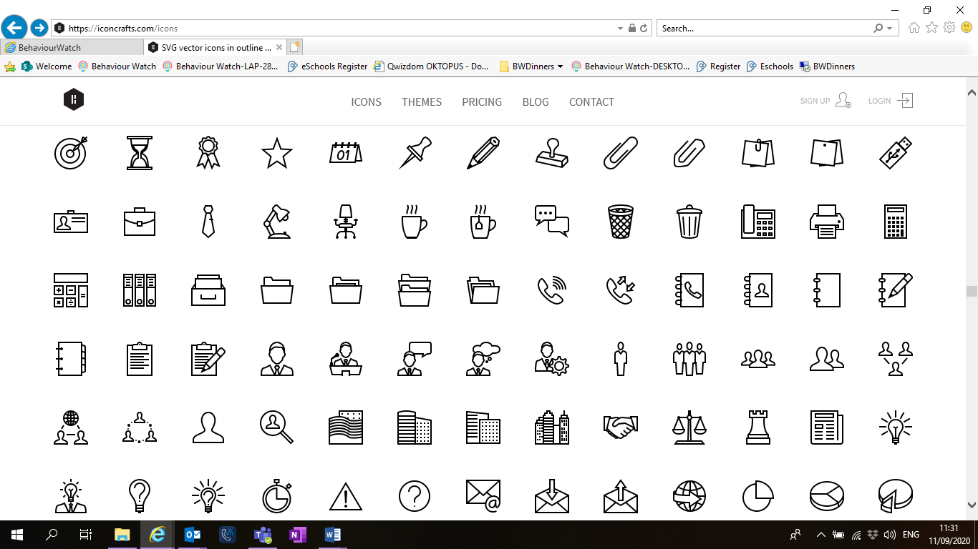

Religious Education and Personal Health and Social Education.

All year groups study a range of religious beliefs in a knowledge capacity. In term 1, we will explore the Christian faith and our learning is based on the key question: ‘What is the ‘Trinity’ and why is it important for Christians?’ Term 2’s focus belief will be Hinduism, considering ‘What do Hindus believe God is like?’ In addition to this, for PSHE we will focus on ‘Health and well being and Relationships’.

If you have any questions or would like more information about how to support your child’s learning, please call or email the school office on 01752 365250 or [westonmill.office@discoverymat.co.uk](mailto:westonmill.office@discoverymat.co.uk) and the class teacher will return your call when they are free. Thank you for supporting our safety measures to protect yourselves and our staff and children.

On the reverse, please find an outline of your child’s learning for Terms1 and 2.

Coming back to school, we have been focusing on settling in and finding time to catch up with our friends and our new classes initially, before moving onto our traditional style of learning through topics.

We are so pleased to see the school full of children again and we are really impressed with the ambition and maturity that the children have shown since coming back to school.

**How you can help:**

Reading, times tables and spellings are the main areas you can make a huge difference with at home, and these are part of what we expect the children to complete as homework each week. Reading books are changed when the children are ready to change their books in school and they have a Reading Journal that they can bring backwards and forwards from school to track their reading at home. Children are still using the Renaissance Reading program. Children should try to read with an adult every day; a good guide is 20mins per day. It is even more helpful if you can ask them questions about what they have been reading, or to predict what they think will happen next.

Each week, your child will be given a list of spellings for their age group. They are tested once a week. You can really support your child by helping them to learn their spellings at home. A few minutes each evening or as you are walking to or from school will make all the difference.

Children in Yr4 will learn timetables facts up to 12x12. Children have access to a website called Timestable Rockstars which they will have their password for and it helps them to practice their tables in an engaging way. You can also help by listening to the children recite their tables or asking questions for the children to answer. When your child is competent on one set of times tables, they will then move on to the next ones to learn.

PE

The children will continue to participate in PE sessions each week. **On a PE day, Yr4, children will be required to come to school in their PE kit for the day.** The children will be going outside and will need suitable outside kit including trainers or plimsolls. School PE kit is a white t-shirt, black or blue shorts, clean socks and trainers or plimsolls. Earrings must be removed for PE by the child, or not worn to school on that day please. Our usual PE day will be **Tuesday**; however, we may take part in other outdoor activities during the week, which will be completed in school uniform.



GEOGRAPHY: In this topic we will be locating and naming continents, countries and cities around the world and identifying their position and significance of latitude, longitude, Equator, Northern Hemisphere, Southern Hemisphere. We will also be comparing their key physical features to the United Kingdom and how they have changed over time.

MATHS: We will continue reinforcing concepts from previous year groups to ensure we continue to build on our learning. In term 2 we will still be focussing on our understanding of place value before using this to develop our knowledge and application of the four operations. Throughout, we will be focussing on securing our fluency and mathematical vocabulary in order to be able to solve reasoning problems.

TERM 2: Bright lights

Book: The Last Stop On Market Street

SCIENCE: In term 2 we will be looking at electricity and identifying common appliances that use electricity. We will give children the opportunity to construct a simple series electrical circuit, identifying and naming its basic parts, including cells, wires, bulbs, switches and buzzers. Using their circuits they will be able to assess whether a circuit is complete by manipulating the switch to open and close. We will also investigate some common conductors.

ENGLISH: We are continuing with a thematic approach to our English learning this year. Using the theme ‘Bright Lights’ we will be exploring a variety of fiction and non-fictions texts as inspiration for our learning. For example, we will be looking at non- chronological reports to give information about different cities around the world. We will still be focussing comprehension skills such as inference, retrieval and prediction. These will be taught using high-quality texts as a stimulus.

ENGLISH: We are continuing with a thematic approach to our English learning this year. Using the theme ‘Potions’ we will be exploring a variety of fiction and non-fictions texts as inspiration for our learning. For example, we will be looking at a set of medieval recipes for folk medicines and home remedies. As part of our thematic approach, we will still be focussing comprehension skills such as inference, retrieval and prediction. These will be taught using high-quality texts as a stimulus.

MATHS: We will start the year by reinforcing concepts from previous year groups to ensure we continue to build on our learning. We will be focussing on our understanding of place value before using this to develop our knowledge and application of the four operations. Throughout, we will be focussing on securing our fluency and mathematical vocabulary in order to be able to solve reasoning problems.

PSHE: In the first two weeks of Term 1, we will be using the key text ‘Here We Are’ by Oliver Jeffers. This will allow us to explore the sense of identity, individually and collectively, relating to the events of 2020. **Term 1:** What strengths, skills and interests do we have? We will focus on recognising our own individuality, how to set ourselves goals and how to be resilient.

SCIENCE: During Term 1 we will be looking at and comparing different materials and categorising them into liquids, solids and gases. We will look closely at how these materials change state when they are heated or cooled, and measure the temperature at which this happens. Finally, we will further look into he role of condensation and how we can apply this to the understanding of the water cycle.

COMPUTING: We will be using computing in a range of different ways to support and enhance our learning. We will be using iPads and Netbooks to learn how to effectively research topics to aid our writing. Online safety plays an important part throughout our school journey, and we will make links to this throughout the year; but especially as we start Year 4.

SPANISH: In Terms 1 and 2 children will be given the opportunity to speak, listen, read and write in Spanish. Studying basic sentence structure using nouns, verbs and adjectives.

MUSIC We have lots of exciting opportunities for art and music in Term 1. We will be using a range of materials to make different sounds, rhythms and tempos to form an original piece of music. In art we will be exploring the bold colours that attract attention on posters for different recipes, remedies and ‘potions’.

DT: This term we will be using our science learning around circuits to design and build our own Christmas trees with lights. We will conduct market research to discover any gaps in the market that we can use in our design phase.

PSHE:

We will be considering respectful relationships. We will be thinking about how we treat others; how others treat us; how to behave appropriately and how to recognise and respond to negative relationships.

TERM 1: Potions

Book: Alice in Wonderland