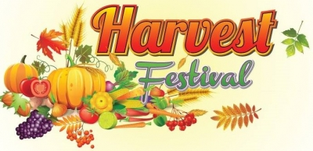
HARVEST ASSEMBLY

We held our Harvest Assembly today. We had a lady in from the local Foodbank (The Trussell Trust) who gave a talk to the children in the assembly about the important work that they do within the community and surrounding areas.
They would really appreciate any donations from the list below.
Items which they would prefer and are in need of are:-

UHT Milk, Long Life Fruit Juice, Cereal
Tinned Meat, Biscuits, Tinned Tomatoes
Dried Goods (pasta, rice)
Toothbrushes and toothpaste
Size 6 Nappies

Please check your items are in date and bring them into school from Monday 7th October to Wednesday 9th October.

