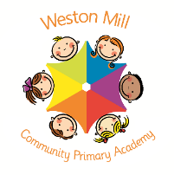

Year 1 Bluebell

Autumn Term Learning

2020-2021

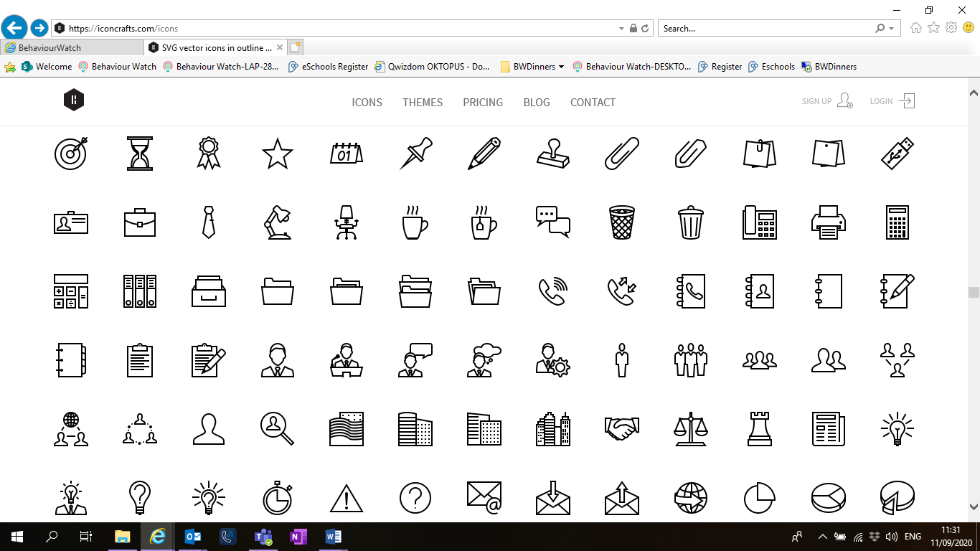

Religious Education and Personal Health and Social Education.

All year groups study a range of religious beliefs in a knowledge capacity. In terms 1 and 2, we will explore **Being special: where do we belong?** and **Why is Christmas special for Christians?** in RE.

In addition to this, in terms 1 and 2 we will focus on **What is the same and different about us?** and **Who is special to us?** In PSHE.

PE

The children will continue to participate in PE sessions each week. **On a PE day, Thursday, children will be required to come to school in their PE kit for the day.** The children will be going outside and will need suitable outside kit including trainers or plimsolls. School PE kit is a white t-shirt, black or blue shorts, clean socks and trainers or plimsolls. Earrings must be removed for PE by the child, or not worn to school on that day please. Our usual PE day will be **Thursday** however, we may take part in other outdoor activities during the week, which will be completed in school uniform.

On the reverse, please find an outline of your child’s learning for Term1 and 2.

Coming back to school, we have been focusing on settling in and finding time to catch up with our friends and our new classes initially, before moving onto our traditional style of learning through topics.

We are so pleased to see the school full of children again and we are really impressed with the ambition and maturity that the children have shown since coming back to school.

**How you can help:**

Reading, times tables and spellings are the main areas you can make a huge difference with at home, and these are part of what we expect the children to complete as homework each week. Reading books are changed when the children are ready to change their books in school and they have a Reading Journal that they can bring backwards and forwards from school to track their reading at home. Children should try to read with an adult every day; a good guide is 15 mins per day. It is even more helpful if you can ask them questions about what they have been reading, or to predict what they think will happen next.

Each week, your child will be given a list of spellings for their age group. They are tested once a week. You can really support your child by helping them to learn their spellings at home. A few minutes each evening or as you are walking to or from school will make all the difference.

If you have any questions or would like more information about how to support your child’s learning, please call or email the school office on 01752 365250 or [westonmill.office@discoverymat.co.uk](mailto:westonmill.office@discoverymat.co.uk) and the class teacher will return your call when they are free. Thank you for supporting our safety measures to protect yourselves and our staff and children.



RE

In RE we will retell religious stories and discuss where do we belong. We will look at Christmas and why is a special festival for Christians.

MATHS Our work this term will focus on addition and subtraction. We will, also, re-visit number bonds to 10. In addition, we will add numbers together or adding more to a number. Finally, we will use number lines to help us add and subtract.

TERM 2: Seasonal Changes

Book: Seren’s Seasons

A stroll through seasons

SCIENCE

This term we will study the seasons and how the weather changes. We will observe and compare the weather during Autumn and through the winter. We will also look how animals adapt in winter.

GEOGRAPHY

As part of our topic we will explore our local area and more specifically our school. We will be doing some map work and we are going to practice directional vocabulary.

PSHE

In PSHE we are going to be talking about families and the importance of people they care for us.

TERM 1: Animals including Humans

Book: The Enormous Turnip

The Gingerbread Man

READ WRITE INC

This term we will be focusing on our sounds from set 1, 2 and also introducing set 3 sounds. We will carry on reading books which have words with sounds we are learning.

READ WRITE INC

This term we will be focusing on our sounds from set 1 and 2 and using these to spell and write words.

ENGLISH

This term we will focus on story settings and how to write a descriptive setting. We will then study information texts about habitats to research and find out about the places animals live.

SCIENCE

As part of our topic we are going to look at animals and the different groups: mammals, birds, fish, amphibians and reptiles. We also going to explore animals’ diet. Finally, we are going to explore the human body and the 5 senses.

ART

As part of our “Animal” theme we will create observational drawings of animals. We will make some animal leaf pictures and create animal patterns and prints.

MUSIC and DT

We will be creating a moving animal puppet using split pins and pullies. In music we will study the carnival of the animals by Camille Saint-Saëns.

ENGLISH

We are going to be studying the traditional tales ‘The Gingerbread man’ and ‘The enormous turnip’ both of these stories have lots of animal characters in them. By the end of the first half term we are going to rewrite one of these stories with our own animals in it!

MATHS Our priority this term is to reinforce prior learning of numbers up to 10 particularly in terms of place value. We will be counting up and down to 10. We will look at one more and one less and will introduce the symbols <,>,= to help us compare numbers.