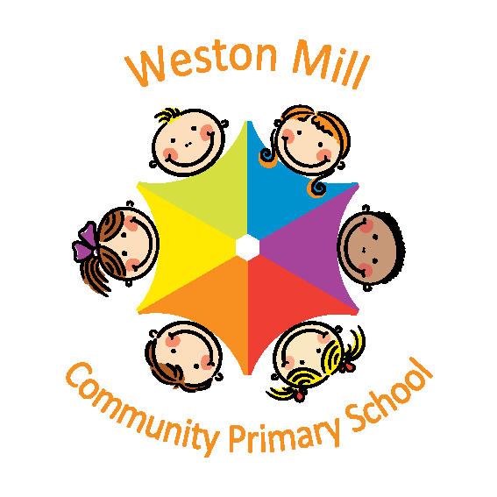
Weston Mill Community Primary School

Application Form for the Nursery
Child’s Name…………………………………………………………………

Date of Birth………………………………………………………………….

Full Names of Parents/Carers
........................................................................................................................................................................................................................................

Full Address……………………………………………………………………
…………………………………………………………………………………………………………………………………………Post Code………………….

Home Telephone Number……………………………………………………
Mobile Phone Contact Number……………………………………………..

Names and ages of any other children in your family………………….
………………………………………………………………………………………………………………………………………………………………………………………………………………………………………………………………

Attendance of any other Nursery prior to Weston Mill
……………………………………………………………………………………
Number of sessions attended and for how long
……………………………………………………………………………….

Why would you like your child to have a place at Weston Mill Nursery?…………………………………………………………………….
……………………………………………………………………………….
……………………………………………………………………………….

Signed…………………………………………….Date…………………..

Please note that when we receive your application your child will be placed on the waiting list according to their date of birth. If we have a place once your child is three years old we will contact you. The Majority of children start Nursery in the September after their third birthday.

Please also be aware that the applications to the reception classes are separate to this application and are dealt with by the local authority.

If you have any questions feel free to call us on 365250

