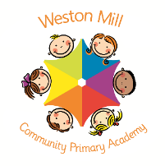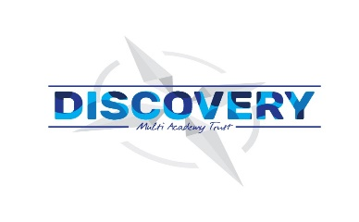

Daisy - Foundation

Autumn Term Learning

2020-2021

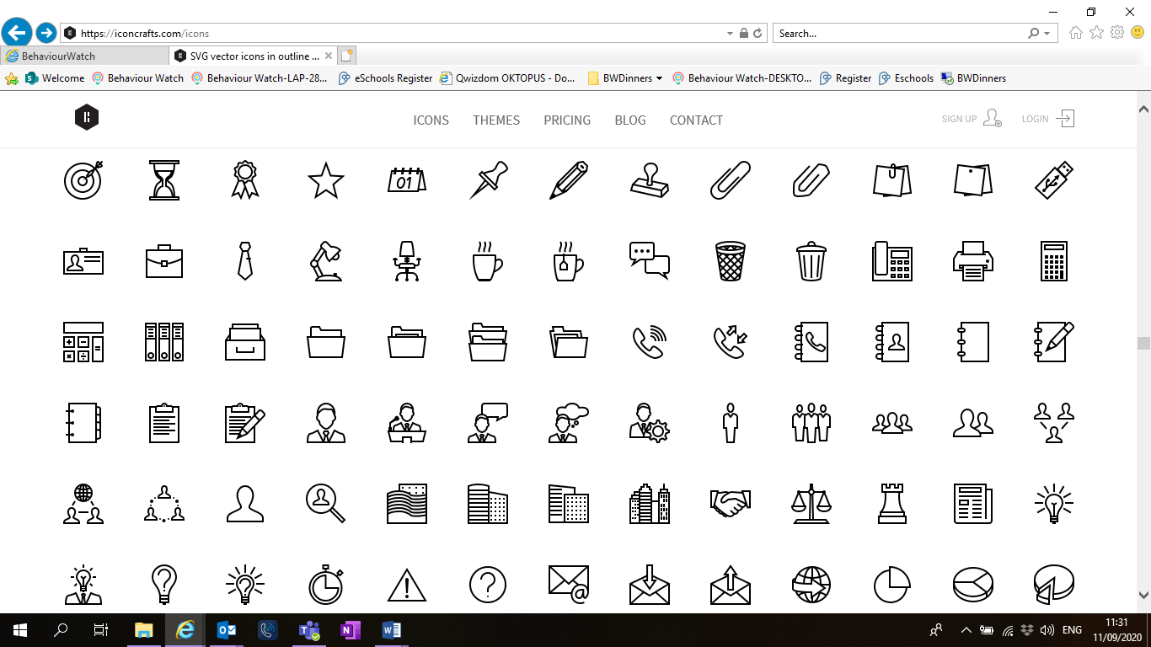

Religious Education and Personal, Social and Emotional Development.

All year groups study a range of religious beliefs in a knowledge capacity. In term 1, we will explore Harvest and what makes us special. In term 2 we will explore which places are special and why and the celebration of Christmas.

In addition to this, in term 1 we will focus on who is in my family? And feelings- what makes us happy/sad? In term 2 our focus will be developing our self-confidence and being able to share and take turns. We will also be looking at how we celebrate special events.

PE

The children in Daisy class will participate in PE sessions each week. **On a PE day, children will be required to come to school in their PE kit for the day.** The children will be going outside and will need suitable outside kit including trainers or plimsolls. School PE kit is a white t-shirt, black or blue shorts, clean socks and trainers or plimsolls. Our usual PE day will be **Friday**; however, we may take part in other outdoor activities during the week, which will be completed in school uniform.

On the reverse, please find an outline of your child’s learning for Term 1 and 2.

Coming back to school, we have been focusing on settling in and finding time to catch up with our friends and our new classes initially, before moving onto our traditional style of learning through topics. We are so pleased to see the school full of children again and we are really impressed with the ambition and maturity that the children have shown since coming back to school.

**How you can help:**

Reading, sharing stories and counting are the main areas you can make a huge difference with at home. In Reception, the children will be bringing home story books from the Read Write Inc. lessons, for you to share together. Some will be picture books; use these as an opportunity to develop language and discuss what is happening in the pictures. Children love to retell stories in their own words and these are a great opportunity for discussion. Others will begin to have books containing simple words, work with your child to sound out these words and blend them together e.g. c-a-t → cat. The books are sent home for enjoyment, if your child is finding it difficult try mixing up your approach for example taking it in turns to read different pages.

Reading books are changed when the children are ready to change their books in school and they have a Reading Journal that they can bring backwards and forwards from school to track their reading at home. Children should try to read with an adult every day; a good guide is five mins per day. It is even more helpful if you can ask them questions about what they have been reading, or to predict what they think will happen next.

If you have any questions or would like more information about how to support your child’s learning, please call or email the school office on 01752 365250 or [westonmill.office@discoverymat.co.uk](mailto:westonmill.office@discoverymat.co.uk) and the class teacher will return your call when they are free. Thank you for supporting our safety measures to protect yourselves and our staff and children.

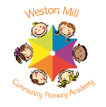

COMMUNICATION AND LANGUAGE During this term we will be retelling and acting out stories and discussing the changes that take place between the different seasons.

EXPRESSIVE ARTS AND DESIGN This term will be creating different characters and objects using junk modelling. We will also be exploring different textures and trying different ways to join materials. In Music we will be singing and learning new songs and playing ring games.

TERM 2: Changes (Autumn/ Winter)

Book: Seren’s seasons.

The three little pigs

COMMUNICATION AND LANGUAGE During this term we will be naming our different body parts and discussing our families and who is in our family. We will also be discussing Autumn and observing the changes we can see happening outside.

PHYSICAL This term we will be exploring our senses and discussing how to keep healthy. This will include talking about a balanced diet- healthy/unhealthy foods and how to keep fit- exercising.

In PE we will be developing our gross motor skills such as running and hopping.

MATHEMATICS This term we will be focusing on matching and sorting, comparing size, mass and capacity. We will also be exploring patterns and comparing different amounts.

LITERACY During this term we will be exploring rhyme and alliteration through reading different stories. We will also be discussing how to handle books carefully when reading them. With our writing we will be focusing on recording and writing our first names and forming the letters correctly and using our sound knowledge to label pictures.

READ WRITE INC (RWI)   
In Reception the children will be following the Read Write Inc programme (RWI). RWI introduces letter sounds and how to write them each week. We practise these regularly and the order we teach them in is:   
m, a, s, d, t, i, n, p, g, o, c, k, u, b, f, e, l, h, sh, r, j, v, y, w, th, z, ch, qu, x, ng, nk   
You can find out how these sounds are pronounced by watching this video on YouTube. <https://www.youtube.com/watch?v=TkXcabDUg7Q>

We will start to read simple 3 letter words as a group, eg m-a-t, s-a-t.

TERM 1: Animals all around

Books: The enormous turnip

The gingerbread man

UNDERSTANDING OF THE WORLD This term we will be exploring how to use the iPads and remote-control toys. We will also be discussing what different houses look like and the different materials that are used to build them.

MATHEMATICS This term the children will be exploring numbers to 5, finding one more and one less, using positional language and exploring 2D shapes.

PHYSICAL This term in PE we will be concentration on jumping and landing appropriately and balancing. We will also be discussing what clothes are appropriate to wear depending on the season.

LITERACY We will be continuing to develop our reading skills through the RWI programme. In our writing we will be exploring letter and story writing and developing our caption writing.

UNDERSTANDING OF THE WORLD We will be discussing the different parts of our body and the similarities and differences between us and everyone else, as well as animals. We will be looking at maps of the World and our local area.

EXPRESSIVE ARTS AND DESIGN This term we will be creating our self-portraits and exploring the creation station and how to use one handed tools such as scissors.

In Music we will be singing lots of nursery rhymes and action songs including Head, Shoulders, Knees and Toes.