Free - Festive Crafts Course
Two session course provided by On Course South West - for Parents/Carers and Families.
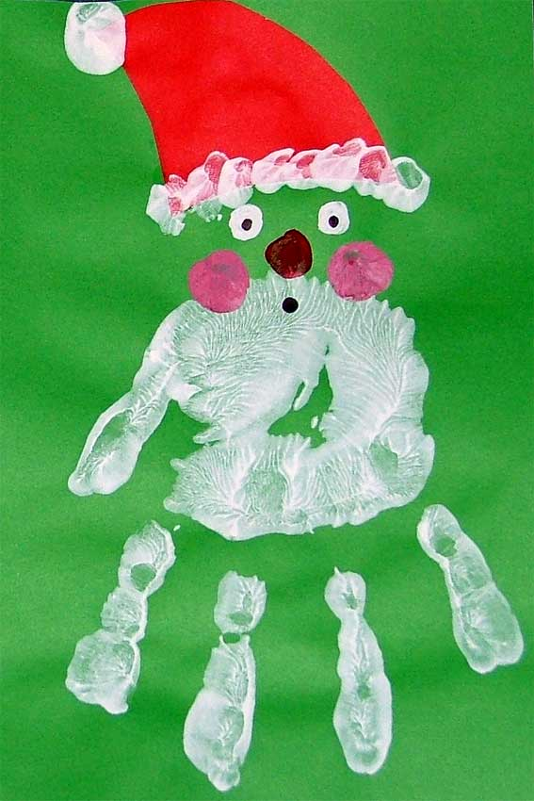When - Thursday 7th December – 9.00am to 11.00am
Tuesday 12th December – 9.00am to 11.00am
Where –Weston Mill Primary Academy - Lunch Hall.
Crèche available for free for children aged 12month – five years
Please contact- Katy Dow (Family Support Worker) on 365250 as Booking is Essential

